Graduate Diploma in IT - 2019

SDV 602 Milestone 3

**Achuthanand Vasudevan**

**Table of Contents**

**1.** **INTRODUCTION** 1

**2.** **MODEL-VIEW-VIEWMODEL ARCHITECTURE** 2

**3.** **GAME DESCRIPTION** 3

**4.** **STORYBOARD & DESCRIPTION** 6

4.1 Login 7

4.2 Register 8

4.3 Game Home 9

4.4 Character Interaction 10

4.5 Game Room 11

4.6 Co-Player Details 12

4.7 Game Room Message 12

4.8 Chat Room Panel 13

4.9 Connection Error Message 14

**5.** **USE-CASE DIAGRAM** 15

5.1 Use-Case Explanation 17

**6.** **CLASS DIAGRAM** 20

6.1 Domain Classes 23

**7. SQLite Database** 25

7.1 Self-Contained 26

7.2 Zero-Configuration 26

7.3 Transactional 26

7.4 Dynamic Datatypes 27

**8. Remote Storage** 28

8.1 JsnDROP 28

**9. Game Storage System** 30

**10. Using Mobile Sensor/Hardware** 31

**11.** **FUNCTIONAL TEST** 32

11.1 Use case Testing 32

11.2 Sensor Testing 36

11.3 Data Update Testing 36

**12. REFERENCES** 38

# **INTRODUCTION**

The game, “**Jack, The Savior!**” is a text-based game where the player needs to input certain text data to continue playing. The text data will be processed and according to the input further actions will decide by the game management system. The game is basically designed and developed using Unity game development platform and using C# for programming.

The text-based environment is made possible in game by creating questioning and answering session between the player and system. The player will have certain health while starting the game and will be reduced by certain amount when the player answered wrongly. The game will start by explaining game situation and then the player can start the game.

There are various approaches exists now for creating game applications, such as:

* Model View Controller (MVC)
* Model View Template (MVT)
* Model View View/Model (MVVM)

etc..

Each approach has their own strength and weakness towards the development. Here I am going to utilize Model View View/Model approach which is also known as MVVM architecture. More details regarding MVVM will be discussed in the later part.

The game is a 2-dimensional (2D) game which supports multiplayer facility. Multiple players can join the game and the winner will be those who finish the game first and with most health.

# **MODEL-VIEW-VIEWMODEL ARCHITECTURE**

As the technology more emerge the need of effective and fast development process is inevitable. By making it possible it is also relevant to keep the system simple without being much complexity. To reduce the complexity of a system patterns are good and effective solution. Model-View-ViewModel or MVVM is one of the several patterns or approaches now using. Here the abstract flow is Model 🡨🡪ViewModel 🡨🡪View.

In traditional User Interface development, developer need to create a view using available window functionalities or similar process and will write all logical implementation. This makes the View large which then creates a strong dependency between UI and binding logic. This led to complex situation in working as team environment and keeping all code in one are leads to ineffective maintainability. This mainly happens because of the tight coupling between the view and logic which includes both business logic, event handling and data binding.

MVVM pattern usually takes advantages of device capabilities and thus it makes use of device memory to extend the application performance. Thus, it allows better user experience which then allows then to have the application on various devices which has varying screen size. MVVM enables the separation of graphical UI from business logic.

* **Model**: It represents the actual data or information that the application deals with. Here in the game the text which moves the story and game is stored using the game models.
* **View**: It is the most familiar part of any system. Here is where the end users really interact with. This visualizes data in a presentable way according to the nature or data and the way user needs it. The view has no knowledge or information about the model. It is fully controlled by a controller. It is where the player interacts with the game. Simple the game interface.
* **ViewModel**: It is what enables the view using the models available. It converts the data to presentable format instead of letting the model aware of user view. In game it is what which accepts the input from the user and then process it for further actions/moves.

# **GAME DESCRIPTION**

“**Jack, The Savior!**” is a fun and entertainment game for children since it doesn’t involve any violent actions or behaviors which will affect the mind of children. The questions designed for the game is similar to brain teaser and basic navigations which helps the children to think more and thus, they can develop their problem-solving skills.

The player has 2 options to play the game. Either the player can start a new game or join some random game. Joining some random game is like joining a game where other players are playing the game thus, those players may have more advantage than the later joined player since they joined earlier.

The game story is as follows.

Once there lived a bunny, Jack with his parents Will and Pink in a village very close to a jungle. In the deep jungle there also lived a fearsome monster in a castle who preyed on innocent animals. One day, Will and Pink along with their neighbor Tinku duck went to jungle in search of food and firewood. They couldn’t find enough food in the outer jungle, so they went deep into the forest. Suddenly they found a garden full of fruits and vegetables and they ran into the garden to pick some. They didn’t know that it was the monster’s garden. By that time the monster came back from his hunting. He found these three uninvited animals in his garden and got angry. He rushed to the garden and caught Will and Pick. Tinku somehow managed to escape from the monster and ran back to the village. He explained everything to Jack and told that only the ones who are blood related can go into the castle and save them. Jack took on oath that he will save his parents by any means.

The game starts here, the player will play the role of Jack. In-order to get inside of the castle successfully the player need to complete first level. Each level will have certain questions to answer. Passing each level successfully will help the player move further inside of the castle & will get elements required to kill the monster and save parents. When all the levels are passed the player will be able to fight with the monster and to release the parents. The player needs to complete all the tasks before he loses his all health.

When the player will start the game, 10 hearts are given as health. Each wrong answer in the game session will reduce 2 hearts. Hence 5 wrong answers/tries will drain all the health and the player will lose the game.

The whole game is divided in to 5 levels. Each level will consist of 3 – 5 questions or directions to navigate. Level 1, 3 and 5 contains brain teaser questions whereas in level 2 and 4, player need to analyze the question and need to track in which direction he/she must move.

The game consists of mainly 6 scenes including game room and certain dialog boxes to show information, warning, danger messages.

* Login scene
  + This scene is loaded first when the game application is loaded. It enables the user to login into the system.
* Register scene
  + This allows new users to create profile in the system.
* Dashboard scene
  + This provides the game story outline and options to start a new game or to join a random game.
* Character Interaction scene
  + This scene will load when the player starts playing the game where Jack and Tinku is exchanging their dialogues.
* Game Room
  + The actual game will run here in game room. The game room is where the game system interacts with the player.
* Co-player detail scene
  + This scene will provide the details of co-players, like their health and time details. The Co-player details scene will show when the player joined a random game and whenever the player needs he/she can open it through Game Room.

UI components used for designing the game are:

* Image
* Text
* InputField
* Scrollbar
* Buttons
* Panels
* Empty Game objects for containing a group or data
* Transforms

Each components and button actions are defined in the storyboard section.

The game room is an active interactive system which acts like a quiz where the player need to think wisely and answer these. All the questions are in child level and no need to think like a pro but think like a child to answer it. The player can only move further only if the answer is correct. Wrong answer reduces the player health by 2 hearts. Hence it is very important to play the game wisely.

Since the game interaction is in the form of a questioning answering session, this will be a great choice for students to increase the analytics as well as problem solving skills. The game interaction is made possible with dynamic question which retrieved from the database. Thus, just altering the questions in the database can extend the game to any level of players.

# **STORYBOARD & DESCRIPTION**

Storyboard is a graphical organizer of the application which needs to be developed. These graphical representations can be visualized in the form of illustrations or images in a sequence which happens in the application. This graphical visualization helps the developers to initiate the development process with the basic design which can be maintained throughout the development. This gives a visual idea on how the game is playing and thus the developers will be able to develop the application real time without having confusion in the design part.

It is a quick way of getting a perspective into what the game will look like prior to the production even before a prototype is developed and tested. These storyboards will help to see where there are gaps in the gameplay actions which will help to give richer experience for the game. While giving the storyboard it is very important to organize it in the proper way so that it will depend on the precise goals of storyboard session.

With storyboard it is equally important to describe what is happening in the storyboard. Storyboard includes the story background of game and the elements required for the game progress. These elements are initiated with the help of user actions. Hence it is essential to describe what will happen when the user initiates the action.

Advantages of storyboard and description are:

1. Will get an overview of the application just with a look.
2. Can improvise the design ideas.
3. Provides concise information.
4. Clear idea about the system before its development

Below explains the story board of game application and the descriptions of user actions related to the game.

## **4.1 Login**

**Board 1**

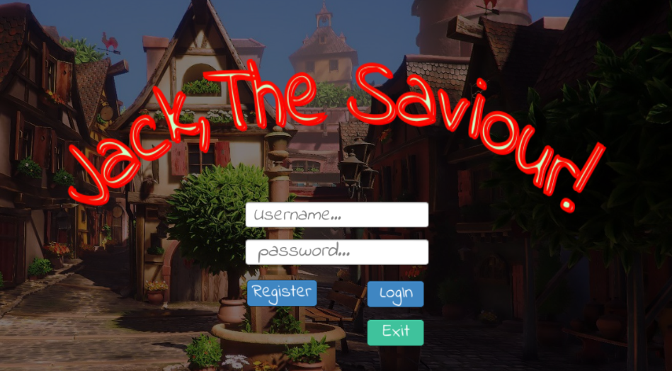

The player need login to the system before start playing the game. Only registered player can login successfully.

|  |  |  |  |  |
| --- | --- | --- | --- | --- |
| Action | What happens? | | | Where to? |
| Click Login | 1. Check if user exists or not? | | |  |
|  | 1.1. If not, throw an error saying so. | | Board 2 |
|  | 1.2. If exists, then validate username & password | |  |
|  |  | 1.2.1. If validation success | Board 3 |
|  |  | 1.2.2. If validation fails, throw error message and stay in the same login page |  |
| Click Register | 1. Opens registration page | | | Board 2 |
| Click Exit | 1. Closes the application | | |  |
| No Internet | 1. If internet is not connected | | | Board 9 |

## **4.2 Register**

**Board 2**

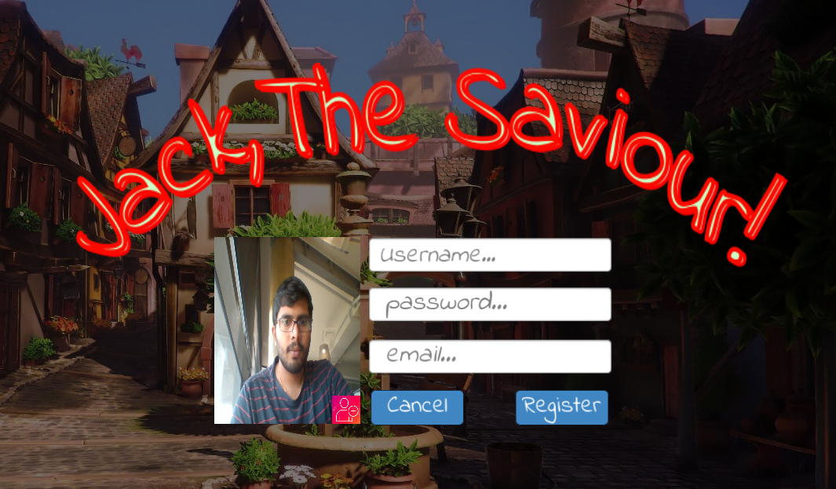

Only registered player can login and play the game. The username should not be an already taken one. The email should be a valid email.

|  |  |  |  |  |
| --- | --- | --- | --- | --- |
| Action | What happens? | | | Where to? |
| Click Register | 1. Check if user exists or not? | | |  |
|  | 1.1. If exists, throw an error saying so. | |  |
|  | 1.2. If not check whether all fields are filled or not | |  |
|  |  | 1.2.1. If not, throw an error saying so |  |
|  |  | 1.2.2. If all fields are filled then register the new user details | Board 1 |
| Click Cancel | 1. Navigate back to login page | | | Board 1 |
| Click native back button |

## **4.3 Game Home**

**Board 3**

Log out

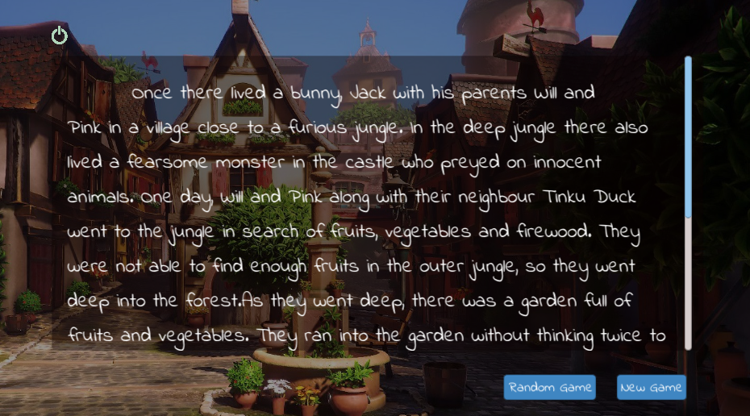

Story area

Once the player is successfully login, the game home will load. Game home will describe the basic story outline and actions to start game, join some random game and log out.

|  |  |  |
| --- | --- | --- |
| Action | What happens? | Where to? |
| Click New Game | 1. New game will create | Board 4 |
| Click Random Game | 1. The player will join in some random game | Board 4 |
| Click Logout | 1. The player will be logged out | Board 1 |
| Click native back button |

## **4.4 Character Interaction**

**Board 4**

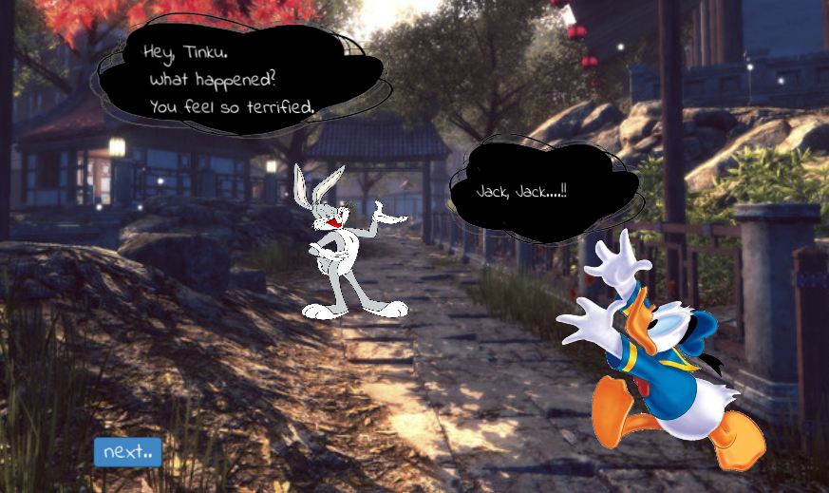

The character interaction screen is where the characters of the game will interact each other. The main dialogue delivery is that the Tinku duck explains the situation happened in the jungle to Jack so that the Jack will get a clear about it.

Clicking Next button will trigger the dialogue delivery once all the dialogues are finished clicking Next button will open the Game Room.

## **4.5 Game Room**

**Board 5**

Chat

Timer

Hearts

Menu

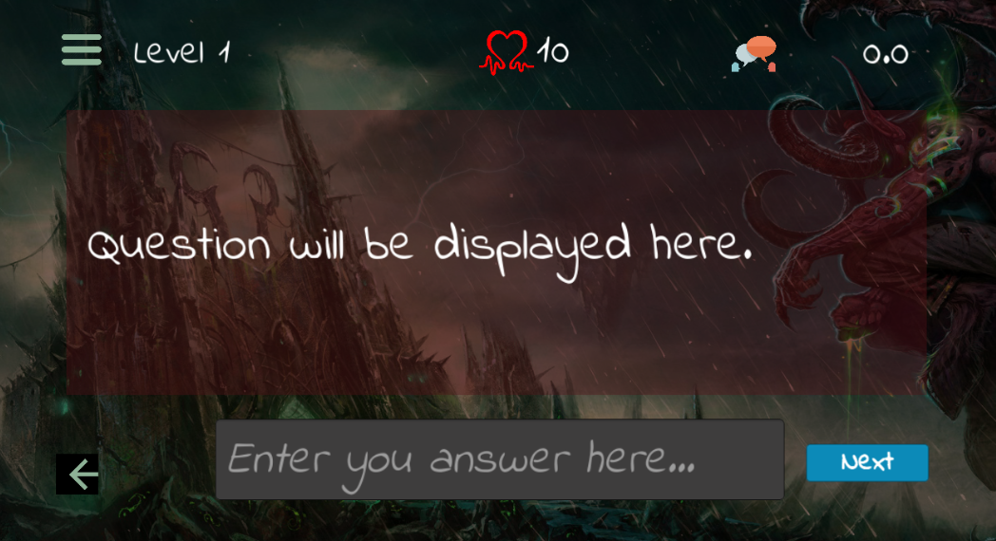

Game will ask question here

Player will input answer here

Back to Game Home

Once the game starts the interaction between player and game will happen here. The game will ask questions and player will answer.

|  |  |  |  |
| --- | --- | --- | --- |
| Action | What happens? | | Where to? |
| Click Menu | 1. Co-Player details will show | | Board 6 |
| Click Chat | 1. Chat room panel will show | | Board 8 |
| Click Back | 1. The player will navigate back to the Game Home | | Board 3 |
| Click Next | 1. The entered answer will check | |  |
|  |  | * 1. If correct next question will appear |  |
|  |  | * 1. If not correct reduce health and stay in same |  |

## **4.6 Co-Player Details**

**Board 6**

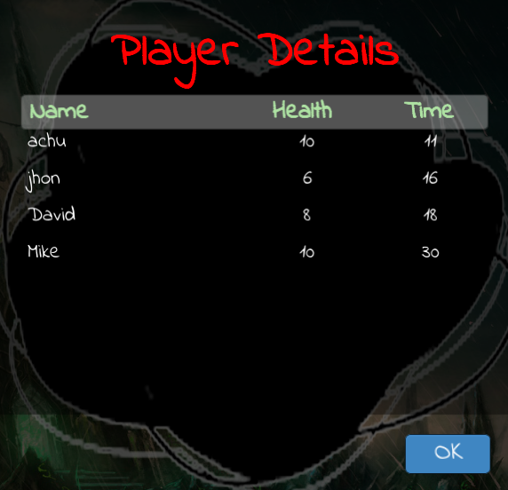

The co-players details will be shown here when clicking menu button in Game Room. Clicking OK button will close the detail page.

## **4.7 Game Room Message**

**Board 7**

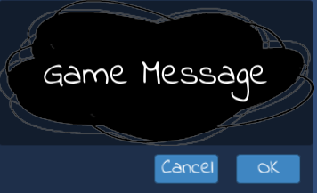

All the game related messages will show in the above message scene.

## **4.8 Chat Room Panel**

**Board 8**

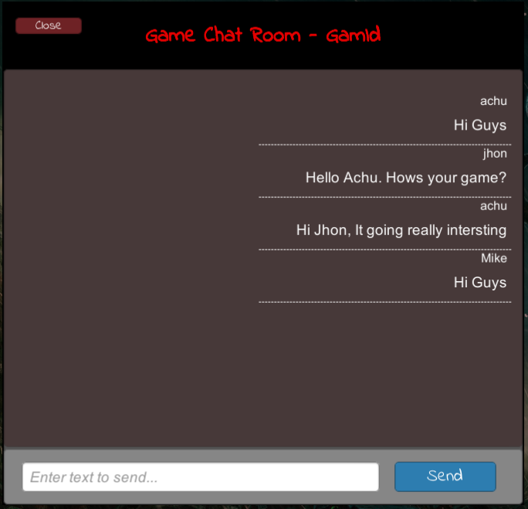

The chat rooms allows the players in a game to interact. The chat room panel only supports small messages since big data cannot be send to the remote storage. Also, no scrolling is implemented. This chat room is only a initial prototype version.

|  |  |  |
| --- | --- | --- |
| Action | What happens? | Where to? |
| Click Close | 1. Chat room will close | Board 5 |
| Click Send | 1. The message will update in the chat room |  |

## **4.9 Connection Error Message**

**Board 9**

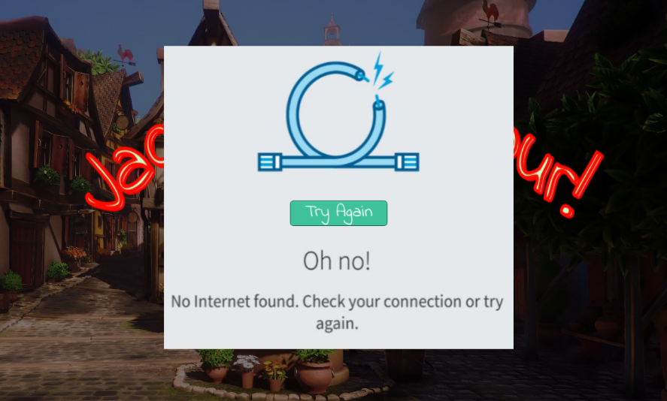

The connection error message will show if the device is not connected to the internet. This checking will happen when the application starts. If the application is successfully connected, then the login screen will load with no issues.

|  |  |  |  |
| --- | --- | --- | --- |
| Action | What happens? | | Where to? |
| Click Retry | 1. Checks the device is connected to internet | |  |
|  | 1.1 If device is connected successfully | Board 1 |
|  | 1.2 If device is not connected | Board 9 |

# **USE-CASE DIAGRAM**

Use-Case diagram is a graphical interface to depict the interaction between actors and system in a most simple and efficient way. The main aim to identify, clarify and organize various requirements required for the system to design. In-order to deploy use case, UML is used which is a standard notation for the mapping of real-world objects and systems. It helps to analyze various scenarios as well as scope of the system.

If the requirement to analyze the system in a deep nature, use-case is not a good choice. It depicts only a high-level overview of the relation between actors and system.

In-order to draw a use-case diagram, it is essential to have a understanding of basic building blocks.

* Actors: Actors are those who interact with the system. It can be a person, an organization or even can be an external system who tries to interact.
* System: System can be considered as a scenario happening between actors and the system.
* Goals: It is what the final aim of use-case, it should describe the while activities to reach the goal.

Here, we mentioned below symbols and notations to represent use-case for the required scenario.

* Use cases are represented using horizontally shaped ovals.
* Actors are represented by stick figures



*  Dependencies are represented by dashed line & Association with a straight line



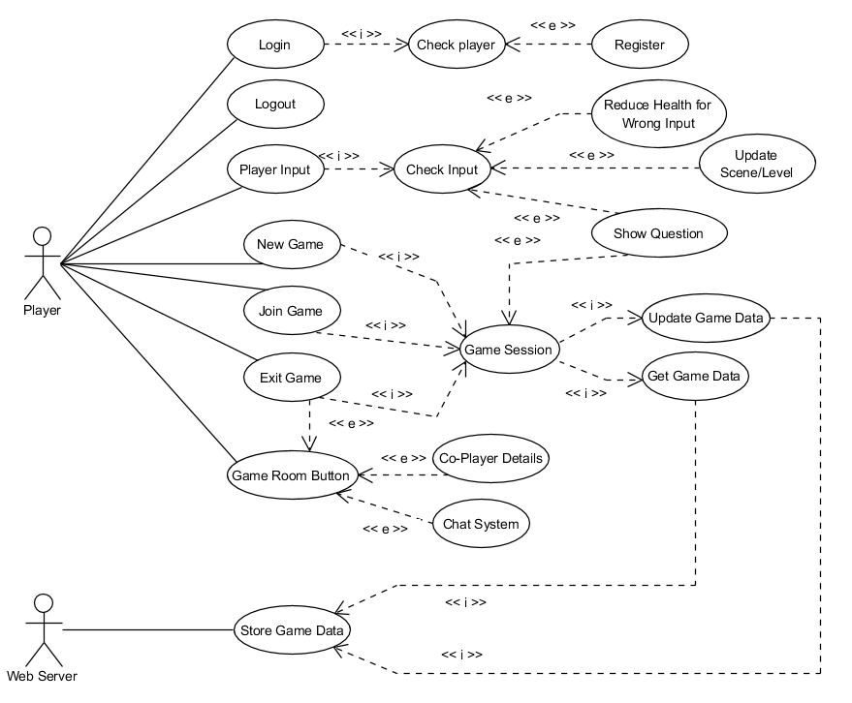

**Use-Case Diagram**

The above shown is the Use-Case diagram of game “**Jack, The Savior!**”. There are basically 2 actors exists for the game, Player and Web server. Player plays the game and Web Server provides the data to serve the game and store data for future use. The use cases are user initiated and game initiated, means user-initiated use cases are those which initiated by users and remaining happens either in the background or by means of game action. Below describes each use cases in detail.

## **5.1 Use-Case Explanation**

1. Login

It defines the process of user logging into the system. The user should have valid username and password to login into the system.

* + If username and password combination is correct the user will successfully enter the game and user status is updated as active
  + If the username does not exist, will throw error
  + If the username and password combination does not exist, will throw error

2. Logout

It defines the process of user exiting from the game. When user logouts the game the status of user is updated to inactive and will update the last login time. This is processed when player clicks the logout button inside Game Home scene.

3. Register

The player should have valid credentials to login in-order to play the game. Register use case is used to register new player.

* + Username should be unique, else throw error.
  + Email should be in valid format, else throw error.

4. Check Player

Check Player use case is used to check whether the user already exists or not. This will be used by Login & Register use case to check whether the user is valid user or not and does username already exists or not consecutively.

5. New Game

New Game use case is used to create a new game when the player did so. The player can start a new game from Game Home scene by clicking New Game button. This will create a new game with 10 hearts as health level.

6. Join Game

Join Game use case is used to join a random game. The player can join random game by clicking Random Game button in the Game Home scene. Here also the player will get 10 hearts.

7. Exit Game

Exit Game use case is used to exit from the game session. The player information will be saved and can continue when comes again later. The exit game button will be available in the left bottom corner of the game room.

8. Game Room Buttons

The game room buttons are mainly used to check the details of co-players in the game to open the chat system. Player details includes the player name, health and time taken which helps to know how far the co-player is. Chat system allows the players to chat between thus it becomes a gateway to interact inside game.

9. Co-player details

Co-player details use case will be used to get the details of player in the same game when game room button is clicked.

10. Player Input

Player Input use case is used to manage the player input in the game. The actual input is the answer to question which is asked.

11. Check Input

This use case is used to check the input is correct or not according to the question asked. If the input is wrong the game will throw an information message and reduce the health level.

12. Reduce Health for Wrong Input

This use case is triggered when the check input use case throws wrong answer message, thus, the health level of the player will be reduced.

13. Update Scene/Level

This use case is used to update the questions/level when the player inputs right answer.

14. Show Question

Show Question use case is used to update the question when player answer the previous question successfully. If the answer is wrong old question will hold else new question will be updated. This use case will be triggered according to the Check Input use case.

15. Game Session

Game session use case is used to manage single game instance. It stores all the information related to the game and will provide necessary information required for the game. It acts as a temporary storage for the game.

16. Update Game Data

Update Game Date use case is triggered by the game session use case when the game data needs to be updated. It happens periodically and when player exists the game.

17. Get Game Data

This use case is used to get the game related information such as questions and answers as well as other data required for the game to run.

18. Store Game Data

This use case is used to store all the game related data where data stored in the game session is transferred to the web server so that it can be retrieved and updated as game needs.

# **CLASS DIAGRAM**

Class diagram is a Unified Modelling Language. It describes the architecture/structure of a system’s classes by associating attributes and methods/operations associated with those classes and the relationships among them.

Class diagram mainly built with :

* Classes
* Relationship between classes

In the diagram a class consists of

* Class name
* Attributes
* Operations/Methods

Relationship between classes can be one of the following types

* Inheritance
* Simple Association
* Aggregation
* Composition
* Dependency

The relationship between classes made clearer and descriptive by using following features.

* Relationship roles
* Navigability
* Visibility of class attributes and operations
* Multiplicity

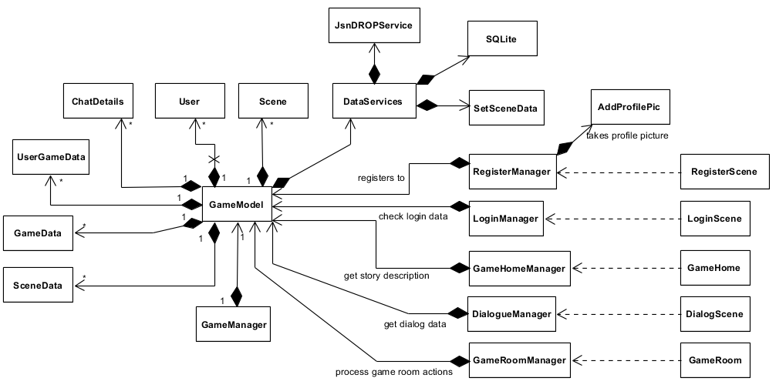

**Class Diagram**

The above shown is the class diagram for the game application. The shown class diagram is a high level representation. It describes only what classes are using and the relationship between them. Hence by progressing development process these will be more clearer and the class diagram will adapt into its descriptive form and may more classes will be added to make the application scalable and maintainable.

Here the Dataservices class enables the connection between game and database when the game starts and maintain this connection for further databse updates. Through GameModel class the game will interact with DataServices class and it then to database to update data accordingly.

The whole game implements the following each segment to run the game properly:

1. GameManager class to control game instance and to initialize the GameModel.
2. GameModel class to provide relevant data and will act as an intermediate between manager classes and DataService class
3. Supporting classes to support game flow.
   1. SetSceneData
   2. AddProfilePic
4. Manager classes to manage the user actions and to populate the user interface according to user actions
   1. LoginManager
   2. RegisterManager
   3. GameHomeManager
   4. DialogManager
   5. GameRoomManager
5. User interfaces or scenes
   1. RegisterScene
   2. LoginScene
   3. GameHome
   4. DialogScene
   5. GameRoom
6. Domain Classes which act as database tables
   1. User
   2. GameData
   3. UserGameData
   4. SceneData
   5. ChatDetails
7. DataServices class to communicate with database

According to the MVVM architecture

* Model is GameModel
* Views are User interfaces or scenes
* View-Models are Managers

## **6.1 Domain Classes**

* **User** – Used to store user details for login purpose. Fields in User domain are
  + Username – primary key
  + Password
  + Email
  + LoginStatus
  + GamesWon
  + BestHealth
  + BestTime
  + LastLogin
* **GameData** – Used to store game details when a game is created by a player. It has
  + GameId – primary key
  + BestHealth
  + BestTime
  + CreateDateTime
  + GameStatus
  + Winner
* **UserGameData** – Used to store game related user details. It contains
  + Id – Primary Key
  + GameId
  + Username
  + Health
  + TimeTaken
  + CurrentLevel
  + IsFinished
  + IsWon
  + StartDateTime
  + EndDatetime
* **SceneData** – Used to store game related data which is required for the interaction between player and game. It has
  + SceneId – Primary key
  + Question
  + Answer
  + Level
* **ChatDetails** – Used to store chat messages. It has
  + Id – Primary Key
  + GameId
  + Username
  + Message
  + SendTime

# **7. SQLite Database**

SQLite is a library that implements small, fast, self-contained, high-reliability, full-features SQL database engine (SQLite, 2019). It is one of the most popular and most used databases in the world. It is already built into mobile phones and most computers and bundled inside lot of applications that people use every day.

The main advantages of using SQLite are (SQLite, 2019):

* Stable
* Cross-platform
* Backward compatible
* Serverless

Before looking to other features, Serverless is the most important feature and it becomes the prominent reason of the popularity of SQLite database.

Normally, Relational Database Management System (RDBMS) such as MySQL, PostgreSQL etc. requires a dedicated server to operate. It uses TCP/IP protocol to send and receive requests through the server. This type of architecture is normally called as client/server architecture model (SQLite Tutorial, 2019).

Below shows the traditional RDBMS client/server architecture:

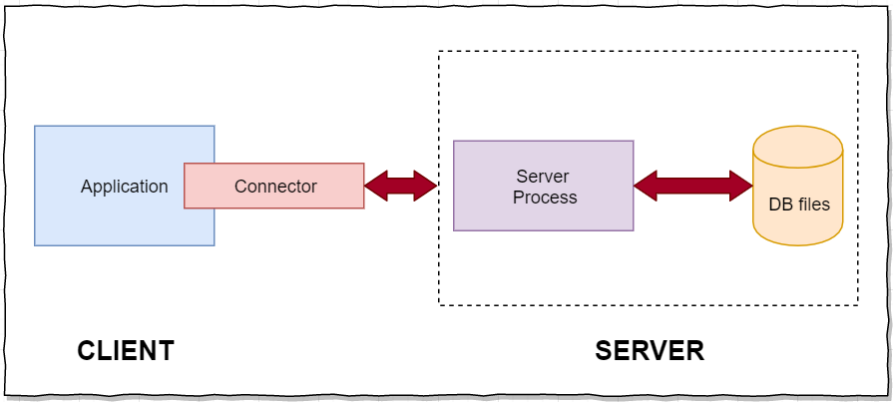

**RDBMS Client/Server Architecture**

Since SQLite is serverless it doesn’t work in this way. It doesn’t need a server to run as above to communicate with the database. SQLite database is integrated with the application that access the database. The application will interact with the database directly.

Below shows the serverless architecture of SQLite.

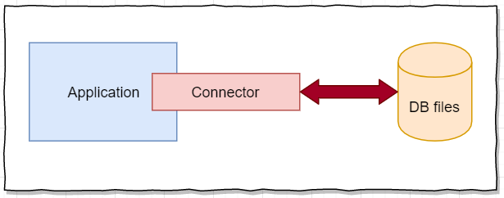

**Serverless Architecture**

## **7.1 Self-Contained**

SQLite requires only minimal support from the operation system as well as from any external library. This enables SQLite to be very useful when working in environments such as embedded devices like phones(any type), game consoles etc. (SQLite Tutorial, 2019). If an application is developing that uses SQLite the developer just need to drop the source code of SQLite into the project and compile it with the application code.

## **7.2 Zero-Configuration**

Since SQLite follows serverless architecture, no need to install SQLite for using it with applications. Hence, there is no server that needs to configure or to start or to stop. Simply SQLite doesn’t use config files.

## **7.3 Transactional**

All the transactional queries in SQLite is fully ACID-complaint. Hence, all the changes within a transaction happens completely or not even in unexpected situations such as crash, power failure etc. occurs.

## **7.4 Dynamic Datatypes**

SQLite can create any value in any column without considering the datatype. Hence the developer can save any type of data in the database.

For a situation, if the model contains a field with datatype Boolean, when running insert query SQLite automatically identifies and save the column type according to that. In this case the Boolean value will considered as 0/1 in the database system. The developer need not to worry whether it return in the same format he want.

# **8. Remote Storage**

Before looking into remote storage, it is important to understand what Server is. A server can be defined as computer program or a device that enables other programs or devices to access and can-do various functionalities (Server(Computing), 2019). These other program or devices are known as Clients and this model is called as Client Server model.

Generally remote storage systems are those sites that enables the users to host, edit, share and synchronize data files, but not much can be achieved using this. Some of the sites that provides these facilities are Dropbox, Google Drive, FTP sites etc. The file format can be anything from pictures to csv files or JSON files.

## **8.1 JsnDROP**

JsnDROP is a remote storage system which stores data in relational tables. The main advantage of using JsnDROP system is that it provides a gateway to interact with data in a way that the request is formatted in JSON format and authenticated with a token. JsnDROP provides connection format facility to communicate with the system. The format is like the relational database queries and thus it provides relational database experience. The query is formatted like JSON files and the system automatically translates this into SQL queries. In-order to use JsnDROP connection format it is required to provide token which authenticates the user and thus can avoid unauthorized access which makes the data secure. This token is important to interact with data in any manner.

Following shows the connection format of JsnDROP to interact with data.

1. Creating a table



1. Store data



1. Retrieve all records



1. Retrieve records according to conditions



1. Delete records



1. Delete records according to conditions



1. Drop table



# **9. Game Storage System**

SQLite is used as a local storage system for Milestone 2 submission and for Milestone 3 submission it is required to use remote storage system. Hence JsnDROP is used as remote storage system. Instead of relying the whole on remote system, SQLite has been also used to store data. Since JsnDROP has various limitation it is not possible to store game related story details. For these, SQLite will be used. Hence while starting the game for the first time the local database will created with the table SceneData and will populate this table with relevant story details which is required for the game.

At the same time all other information are stored in remote system. Tables such as User, GameData and UserGameData is created in the remote system and will be populated according to the interaction with the game application.

Local SQLite database will be used only to read story details and no update operations will execute on the local database. Whereas the remote database will update frequently in following cases:

1. New user registration
2. When user login
3. When user starts new game
4. When user joins random game
5. When user plays the game
6. When user leave the game
7. When user logouts

# **10. Using Mobile Sensor/Hardware**

The game application is focused to be working on a mobile device which runs on Android or IOS. Here the application is developed to run on Android. As a part of utilizing mobile sensors/hardware, following are used:

1. Device front camera

Front camera is used to take the profile picture when the user registers in the game system. This will be saved locally in the device. The profile picture preview will display in the game home screen. The profile picture is optional, and the user can register without the picture. The image will load in game home only if it exists in the local.

Native Unity functionality is used to access the camera. Unity provides WebCamTexture class to access device cameras. WebCamTexture is a derived class of Texture. It provides the functionality to get the live camera feed and to get the picture details. Coroutine is used here to take the snapshot when clicks the Red button on the bottom right corner of the live feed.

1. Tilt sensors

This is used to predict the directions which is required to play level 2 in the game. This is achieved by using Input class which used to read the axis details set up in the conventional game input and to access multi touch/accelerometer values on mobile devices. These devices can track multi finger touch on the screen and these details can be accessed by using Input.touches property array.

The tilt sensors are worked as the device moves and the accelerometer values are reported which ten can be accessed using Vector3 class. This is accessed by Input.acceleration property and Input.deviceOrientation provides the discrete evaluation of device orientation in 3D space.

The tilt reading are monitored on every frame update when the current level of user becomes two.

# **FUNCTIONAL TEST**

The functional test makes sure that the system works perfectly fine without having issues with the functional requirements/specification. These are tested by giving input and analyzing the output. Below shows some of the functional testing cases for milestone two.

## **11.1 Use case Testing**

|  |  |  |  |  |
| --- | --- | --- | --- | --- |
| **Use Case** | **Function being Tested** | **Initial System State** | **Input** | **Expected output** |
| Login  Check Player | Check user login credentials | Login Scene shown with empty fields | Enters username & password and clicks Login button | Login successful - Display Game Home Scene |
| Existing username – Display error saying so |
| Invalid username password – Display error saying so |
| Empty fields – Display error saying so |
| Register  Check Player | Check user register data | Register Scene shown with empty fields | Enters username, password & email and clicks register | Valid data – Successful Register message is shown, and Login scene will load |
| Existing username – Display error saying so |
| Invalid email – Display error saying so |
| Empty fields – Display error saying so |
| Logout | Log out user session | User already logged in and Game home scene shown | Click logout button | Successfully end of user session and navigates to Login Scene |
| New Game | Create a new game default health is assigned to player | Game home scene shown, and no new game created | Click New Game Button | New game is created and Loads the Game room with default health and the timer starts running |
| Join Game | Multiple players can join a running game with default health assigned | Game home scene shown, and should have some games running | Click Random Game button | Player will be added to a running game with default health and timer starts running |
| Game session | To store data temporarily a game session is created | No data regarding the current session | Click New Game/ Random game button | Game session with default values will be created |
| Get Game data | To retrieve game related data when a new game is created, or new player joins existing game | No game data to run the game | Click New Game/ Random game button | Game data required for the successful game running will be provided |
| Update game data | To update game related data when a player joins the game or out of the game | No game data to update since no new player joined the game or no existing player out of the game hence same game data as game session | New player joins the existing game or existing player out of the game | Updates the player actions in the server |
| Player Input  Check Input | Player input the answer of questions asked which is then processed to check whether the answer is correct or not | The text input field in the game room is empty. | Player input the answer to the question | Correct answer – Show correct answer message and load next question |
| Wrong answer – Show wrong answer message and hold the same question |
| Reduce health for wrong input | The player health is lowered when the answer is wrong message is shown and clicks ok | Wrong answer message is displayed but not clicked the ok button | Player clicks ok button in the message window | The player health will be reduced by 2 |
| If the health becomes 0 game over message will display |
| Show question/Update Scene/level | Upgrading to higher level or updating the questions when correct answer is given | Previous level question or same level question | Player input answer to the question asked | If the answer is correct next question will display |
| If all the questions in a level is correct then player will be upgraded to higher level |
| Game room button,  Co-player details | Showing the co-player details | Player is playing the game in game room | Player clicks menu button in the game room | A window will pop-up with details of co-player in the game. If no players in the game then will show message saying so |
| Exit Game | Player will be out of the game | Player is playing the game in game room | Player clicks the back button in the game room | The game data will be updated, and the player will be out of the game. |

## **11.2 Sensor Testing**

1. Accessing Camera

The camera is tested by opening Register scene and checks whether the application is accessing live feed.

1. Tilt Sensor

The tilt sensor reading is testing when the player reaches level 2.

* Tilt to right - Input field should update with value ‘East’
* Tilt to left – Input field should update with value ‘West’
* Tilt to down – Input field should update with value ‘North’
* Tilt to up - Input field should update with value ‘South’

## **11.3 Data Update Testing**

With these functional testing it is also tested that whether the database is updated correctly when:

1. New user is created
   1. User table is updated with new user details
2. A user gets login
   1. Status column is updated
   2. LastLogin column is updated
3. A user gets logout
   1. Status column is updated
4. New game is created
   1. GameData table is updated
   2. UserGameData table is updated with the game related user details
5. Joined a random game
   1. UserGameData table is updated with new user to the existing game
6. When the answer is correct/wrong or when a level is updated
   1. User table is compared with existing score details and will get updated if required
   2. UserGameData table is updated with new score details
7. When a user fails/won the game
   1. User table is compared with existing score details and will get updated if required
   2. UserGameData table is updated with new score details
8. When user chats
   1. The ChatDetails table will update with each chat messages.

# **12. REFERENCES**

*Functional Testing*. (2019, October). Retrieved from Software Testing Fundamentals: http://softwaretestingfundamentals.com/functional-testing/

*Model View ViewModel Explained*. (2019, October). Retrieved from Wintellect: https://www.wintellect.com/model-view-viewmodel-mvvm-explained/

*Server(Computing)*. (2019, November 14). Retrieved from Wikipedia: https://en.wikipedia.org/wiki/Server_(computing)

*SQLite*. (2019, October). Retrieved from SQLite Documentation: www.sqlite.org/index.html

*SQLite Tutorial*. (2019, October). Retrieved from What is SQlite: https://www.sqlitetutorial.net/what-is-sqlite/

*The 5W's of MVVM*. (2019, October). Retrieved from Sagitec Blog: https://www.sagitec.com/blog/the-5ws-of-mvvm

*Understanding the basocs of MVVM design pattern*. (2019, October). Retrieved from Microsoft: https://blogs.msdn.microsoft.com/msgulfcommunity/2013/03/13/understanding-the-basics-of-mvvm-design-pattern/